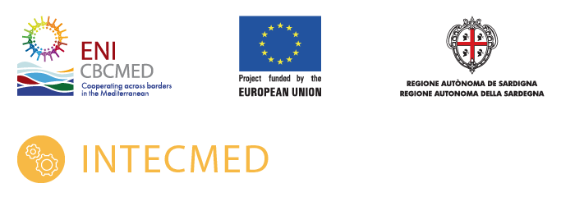
Incubators for innovation and technological transfer in the Mediterranean
INTECMED B_A.2.1_0063
Financed by the ENI CBC Med 2014 2020 Programme

Application form
Deadline for submission of application: 16th of November 2022

Title:

Location(s):

Name of the applicant

Name of the co-applicants

Applicant’s contact details for the purpose of this action
Postal address:
Telephone number:
Contact person:
Contact person’s email:

- Summary of the proposal
Title of the proposal:
Location (region - country):
Maturity of the proposal (business idea, business model, sales, growth)
Launch of the activity (date):
Sector:
Description (100 words)

- Description of the business idea
Value Proposition
Customer Segmentation
Market in Egypt
Business Model
Competitors

- Description of innovation
Innovative technology
TRL
Relevant Technologies
IP

- Description of the impact of the business idea
Scalability
Internationalization
Jobs
Attract Investment
Impact

- Description of the feasibility of the business idea
Business Validation
Technical Validation

- Relevance
Mentorship Programme
Subgrants

- Indicative action plan

Activity | 1 | 2 | 3 | 4 | 5 | 6 | 7 | 8 | 9 | 10 | 11 | 12
- Experience of applicant and co-applicants
Please provide any of the following information:
- Brief presentation of the promoter(s) of the business idea: education, professional experience and any other relevant information.
- Networking capabilities, relationship with startup ecosystem, participation in business associations and/or incubation programmes, and any other relevant information.
- Relationship with R&D organizations, experience in technology transfer, projects awarded with public grants, etc.
Brief
Networking

- Identification of applicants and co-applicants
Applicant
Name
Legal status (natural person, legal entity, research group…)
Registration number (ID number for natural persons – VAT number for legal entities. For research groups, please, include ID number of the lead researcher)
Address
Telephone number
Website of the organisation

Declaration by the applicant
The applicant represented by the undersigned, being its authorised signatory (and, in the context of the present application, representing any co-applicant(s) in the proposed action), hereby declares that:
Capacity:
- The undersigned has the capacity and permission to participate in this programme, from the entity to which he or she represents, if so.
- The proposal is original, and the applicant is entitled to present this application.
Eligibility:
- The applicant and the co-applicant(s) are not in any of the situations excluding them from participating in contracts foreseen by the applicable legislation.
- The applicant and each co-applicant (if any) are eligible in accordance with the criteria set out in the call text and commit to comply with the ethic clauses and code of conduct included in the call text.
- In case of co-applicants, the applicant undertakes to comply with the obligations foreseen with the principles of good partnership practice.
Communication and dissemination:
- The applicant accepts that the information provided in section 1 of the application form (Summary of the proposal) may be used to communicate the results of the call.
- If selected, the applicant will specifically mention the support received from INTECMED project, fulfilling the visibility specifications included in the call text.
- If selected, the applicant accepts to participate in INTECMED communication activities, that may include interviews, videos or articles aimed to disseminate the achievements and results of the project. If the applicant is in the process to protect intellectual property resulting from the activities, these limitations must be specifically communicated to the managers of the programme, to avoid the disclosure of these information.
Commitments:
- The applicant commits to participate in a short interview with INTECMED evaluation committee, that may be held online, if necessary, as an opportunity to present the proposal and provide additional information for the evaluation process.
- If selected, the applicant is directly responsible for the participation in the Mentorship activities with the co-applicant(s) if any and is not acting as an intermediary.
- If selected, the applicant demonstrates the intention to actively participate in the activities included in INTECMED Mentorship programme and make the most of it.
- If selected, the applicant commits to participate in the exhibitions and events in which INTECMED project will be present. It includes an international entrepreneurship event, Patras IQ Innovation Quest, and regional events.
- The applicant understands that this application is focused on the participation in INTECMED Mentorship programme, and that the possibility to be awarded with one of the subgrants will be addressed in a specific evaluation process that will take place once the Mentorship programme has been completed.

Processing of data:
I acknowledge that if I participate in spite of being in any of the situations for exclusion or if the declarations or information provided prove to be false, I may be subject to rejection from this procedure.
Signed on behalf of the applicant
Name:
ID number:
Organisation:
Position:
Signature:
Date and place:

Mandate of the co-applicants
The co-applicant(s) authorise the applicant <name of the applicant> to submit on their behalf the present application form, as well as to represent the co-applicant in all matters concerning this call.
I have read and approved the contents of the proposal submitted to the managers of the call. I undertake to comply with the principles of good partnership practice.
Name:
ID number:
Organisation:
Position:
Signature:
Date and place:

